Cairo University  
Faculty of Computers and Information



**CS251**

**Software Engineering I**

Software Design

Youssef Salah mohammed

Youssef Maher Danial

Ahmed Mohsen Abd El Rasig

Ahmed Hassan El Doma

Dec,2019

Contents

Team 3

Document Purpose and Audience 3

System Models 3

I. System Decomposition 3

II. Class diagrams 6

Important Algorithm 7

III. Sequence diagrams 7

Class - Sequence Usage Table 9

Ownership Report 10

Policy Regarding Plagiarism: 10

References 10

Authors 10

# Team

|  |  |  |  |
| --- | --- | --- | --- |
| **ID** | **Name** | **Email** | **Mobile** |
| 20170344 | Youssf Salah Mohammed | Ys2339692gmail.com | 01124075089 |
| 20170347 | Youssef maher Danial | Youssedmaher42@gmail.com |  |
| 20170373 | Ahmed Mohsen Abd El Rasig |  |  |
| 20170379 | Ahmed hassan el doma |  |  |

# 

# Document Purpose and Audience

This Document is a Software Design Specification document which describe the design stage which include System Decomposition , System Decomposition and sequence digrams of our Social Network Back-End API.

Audience of this document is supposed to be:

-Project Manager

-Software Engineers

# 

# System Models

## I. System Decomposition

## 

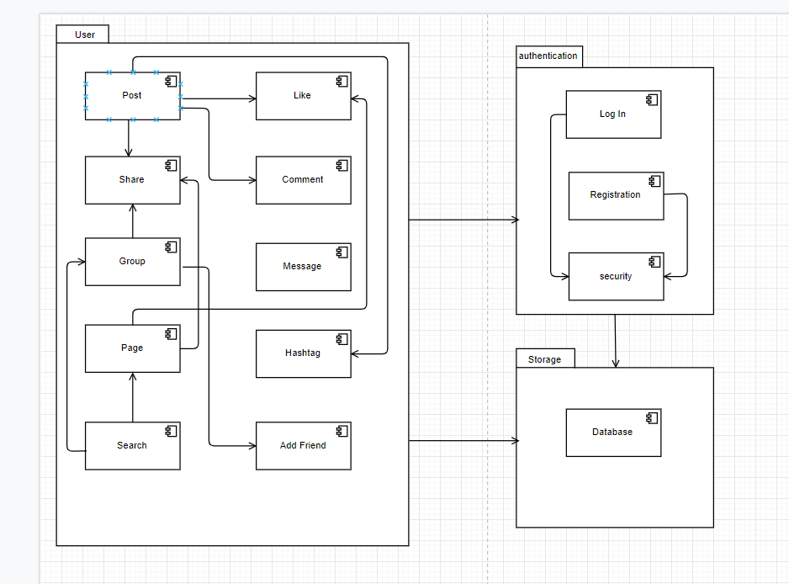

## II. Class diagrams

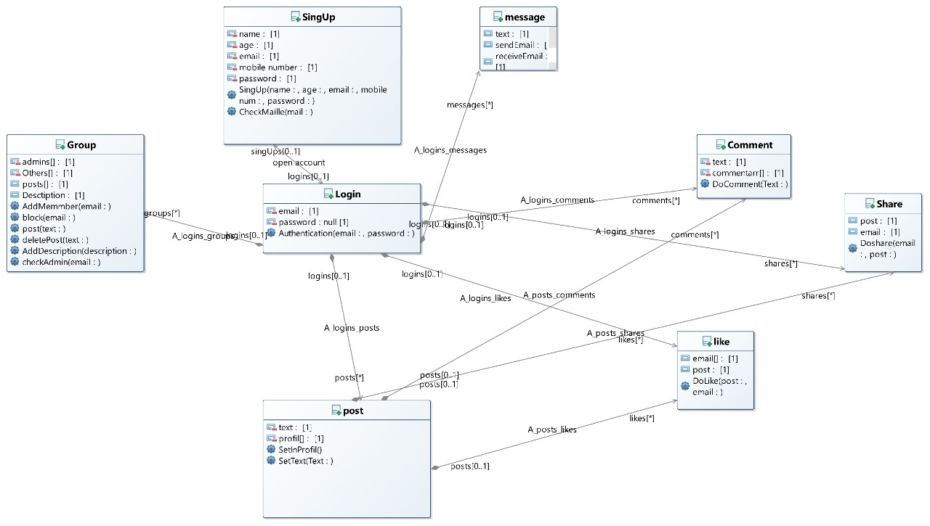

**Classes description:**

| **Class ID** | **Class Name** | **Subsystem ID** | **Description & Responsibility** |
| --- | --- | --- | --- |
| 1 | Log In | ID.1 | Responsible for log in process with all its actions. |
| 2 | Sign UP | ID.2 | Responsible for Sign Up process with all its actions. |
| 3 | Post | ID.3 | Responsible for making a post and managing it . |
| 4 | Group | ID.4 | Responsible for making a group and managing it. |
| 5 | Message | ID.5 | Responsible for create chat groups , sending messages , receive them and chatting with friends. |
| 6 | Comment | ID.6 | Responsible for make a comment in a post in a specific direction and managing it. |
| 7 | share | ID.7 | Responsible for make share for post in a specific direction and managing it. |
| 8 | like | ID.8 | Responsible for make a like in a post in a specific direction and managing it. |

### Important Algorithm

* **There is no** **any method in a class is implementing a complex algorithm.**

## III. Sequence diagrams

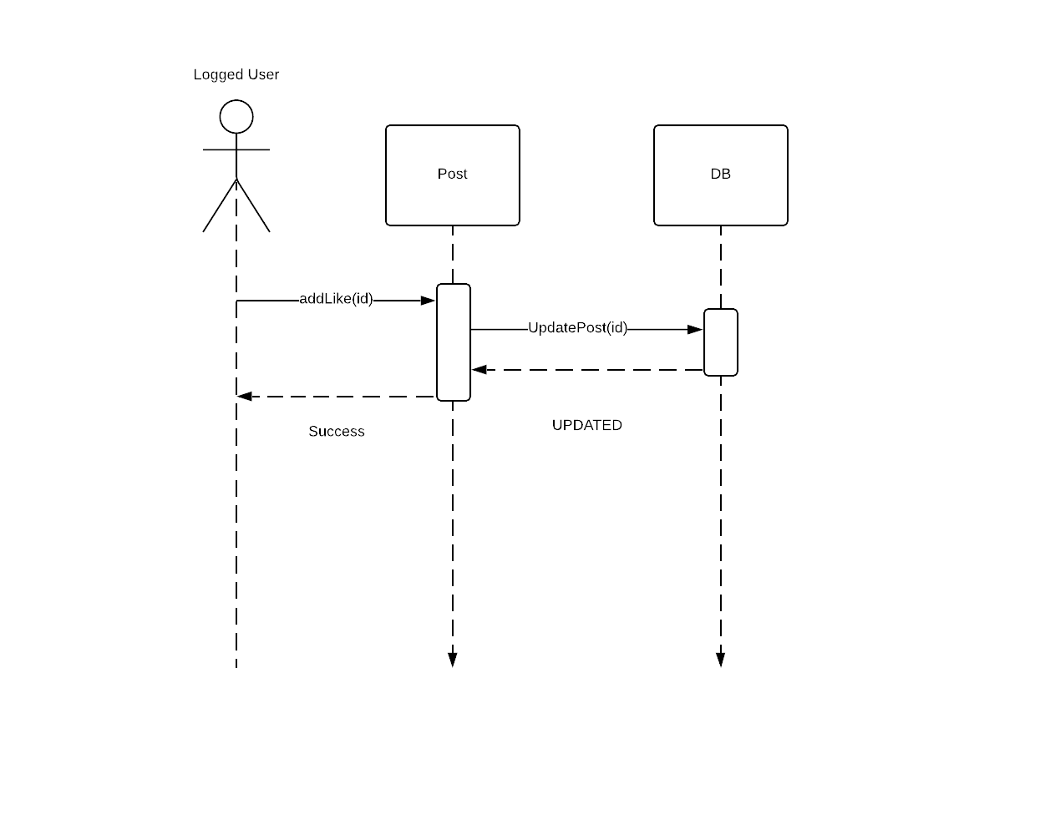

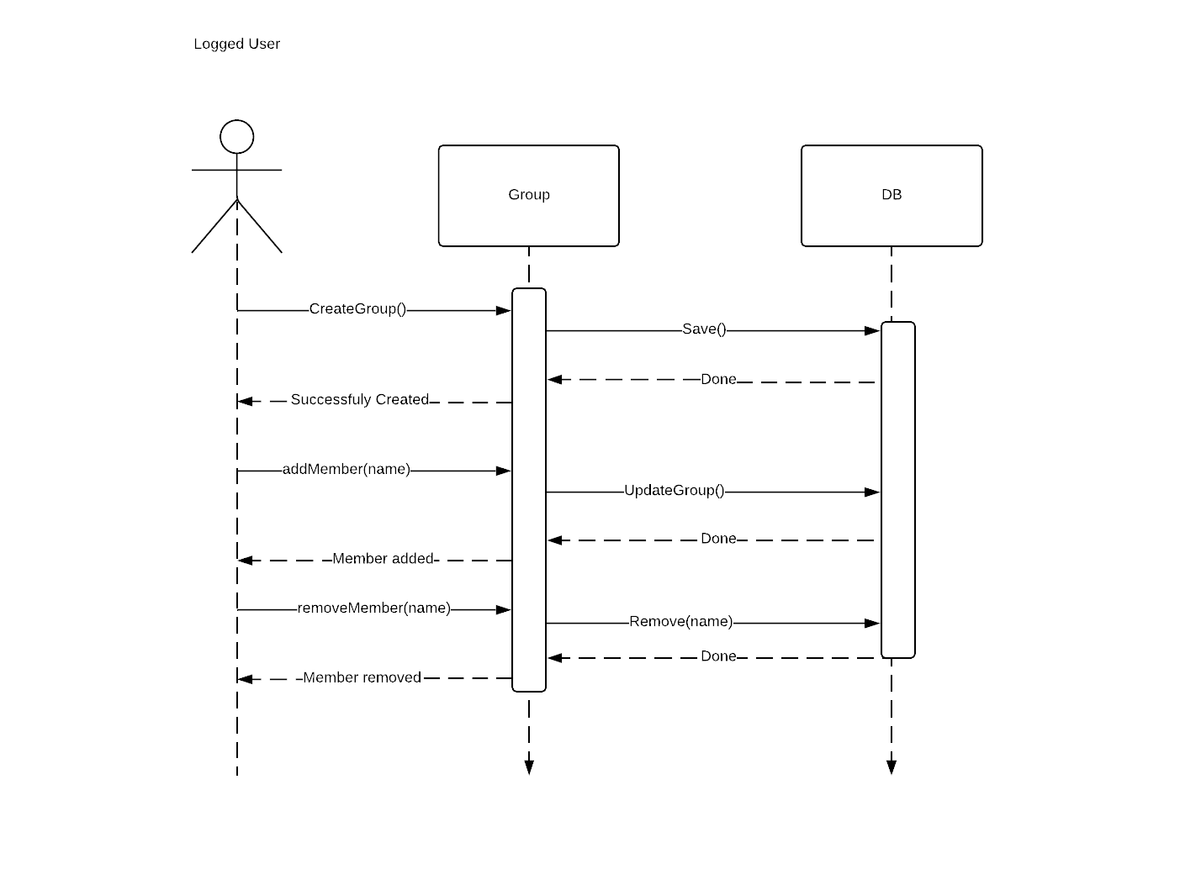

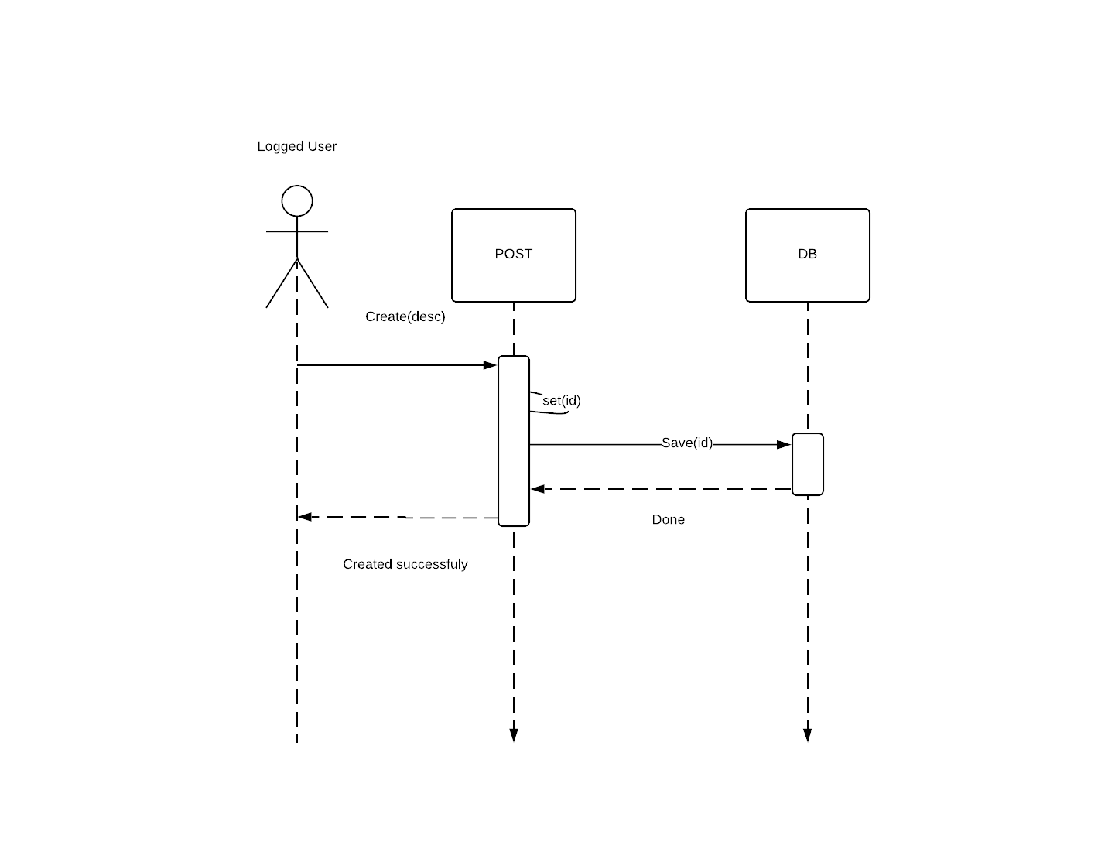

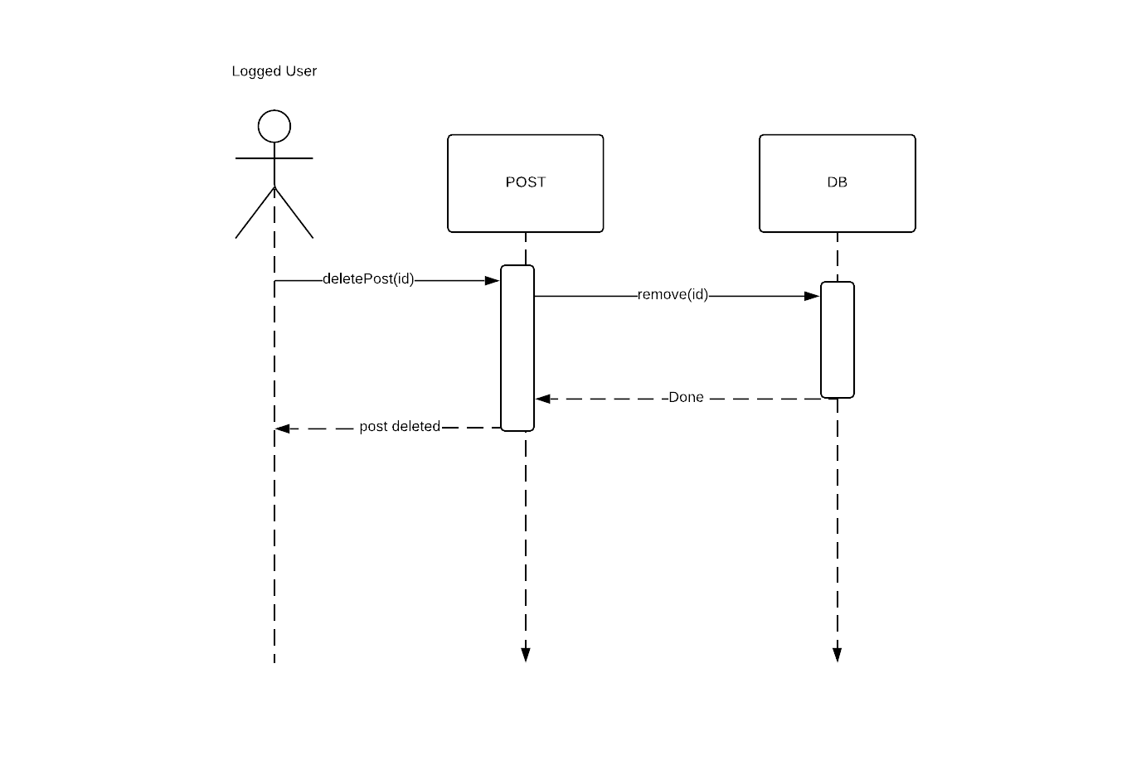

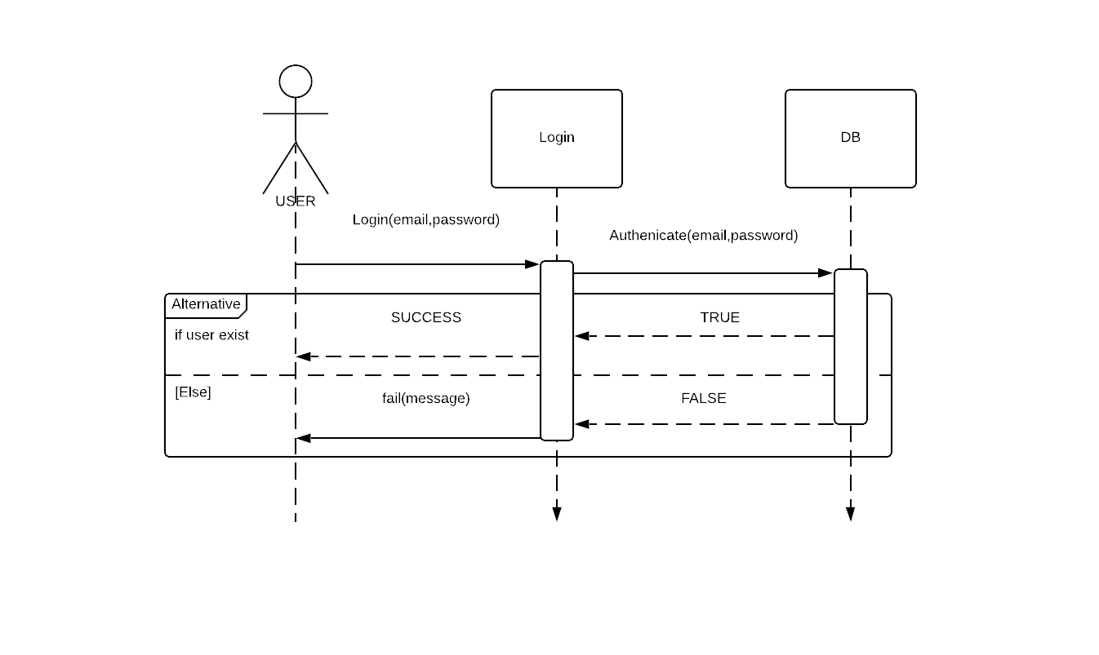

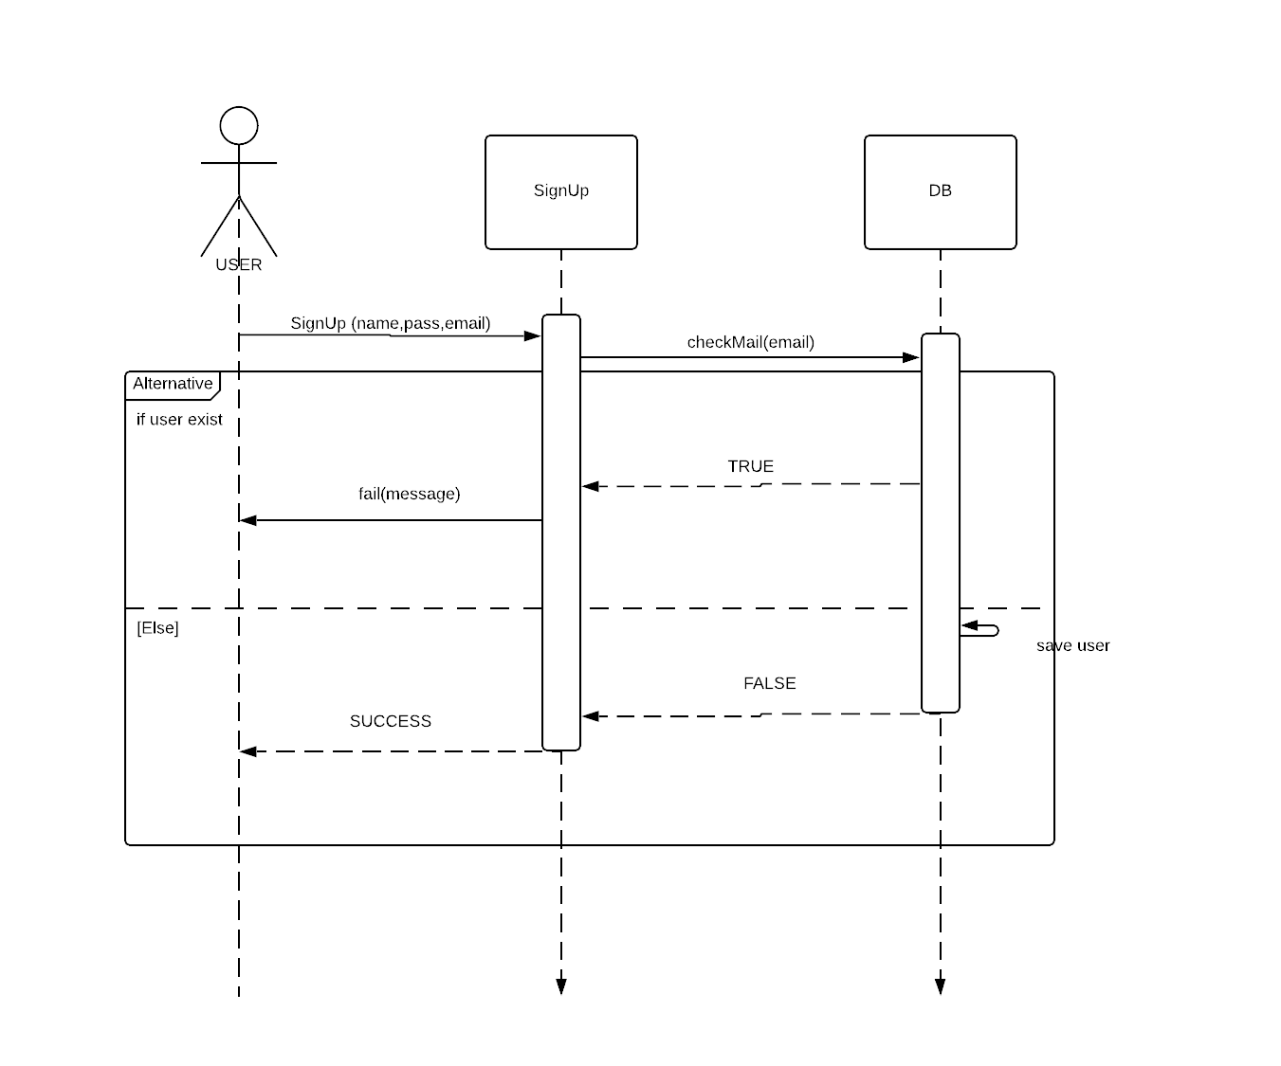

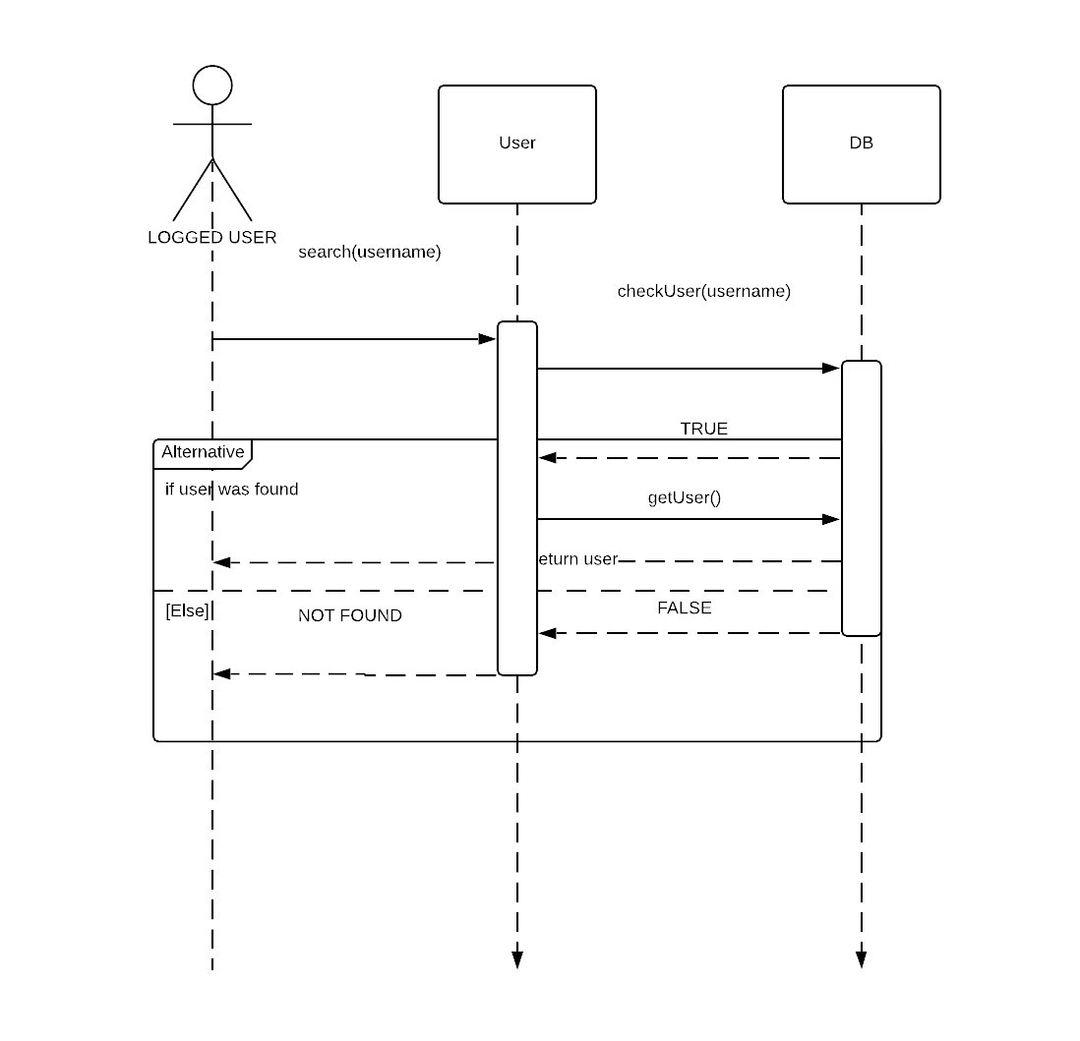

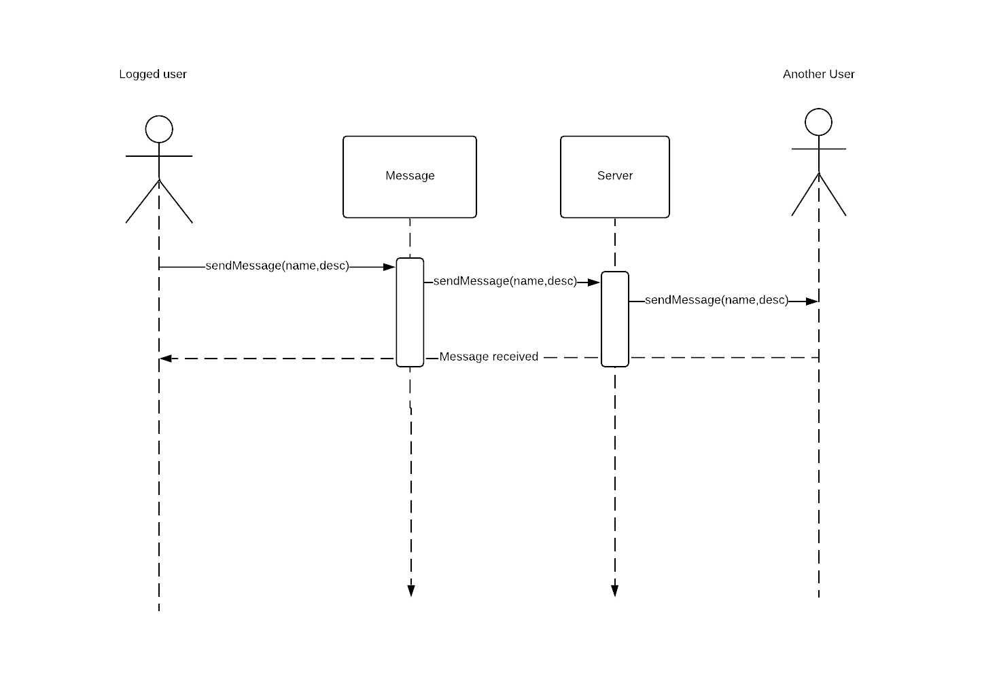

### Class - Sequence Usage Table

|  |  |  |
| --- | --- | --- |
| Class Name | Sequence Diagrams | Overall used methods |
| Post | 1,3,4 | Create,addLike,set,deletePost |
| Login | 5 | Login,fail |
| Signup | 6 | signUp,fail |
| Group | 2 | createGroup, addMember,  removeMember |
| Message | 8 | sendMessage |
| User | 7 | Search |

# Ownership Report

|  |  |
| --- | --- |
| **Item** | **Owners** |
| Sequence diagrams | *Youssef Maher* |
| Class Diagram | *Youssef Salah* |
| System Decomposition | *Ahmed Mohsen, Mohamed Hassan* |

# Policy Regarding Plagiarism:

# Students have collective ownership and responsibility of their project. Any violation of academic honesty will have severe consequences and punishment for ALL team members.

# References

* Youtube.com
* Google.com

# Authors

* Youssef Salah
* Youssef Maher
* Ahmed Mohsen
* Ahmed Hassan